**Pick Your Flicker**

## Table of Contents

1. **Introduction**
   1. *Purpose*
   2. *Scope*

# The Overall Description

* 1. *Product Perspective*
  2. *Product Functions*
  3. *User Characteristics*
  4. *Constraints*
  5. *Assumptions and Dependencies*

# External interface Requirements

* 1. *User Interfaces*
  2. *Hardware Interfaces*
  3. *Software Interfaces*

## System Features

1. **Other Non-Functional Requirements**
   1. Performance Requirements
      1. Login
      2. List Movies
      3. Book Ticket
      4. Movie Booking Details
   2. *Software System Attributes*

5.2.1. Security

5.2.2. Reliability

5.2.3. Availability

5.2.4. Maintainability

5.2.5. Portability

5.2.6. Accessibility

# Introduction

The project Pick Your Flicker is a web based application that allows the customer to login and handle all the movie activities in online. Using this software, the user need not to stand in queue for booking a ticket and at a same time admin will feel comfortable to keep a check on the movie and the booking instead of handling it with paper. This system will give them flexibility to manage everything from a single portal based on their login. Viewers can view the movie which are being shown in the theatre and also they can book the tickets. Through this application the customer can interact with a user friendly interface that enables them to performs booking and view the ticket.

### Purpose

The main purpose of Pick Your Flicker is to provide the another way for booking a ticket by the customer. This system is aimed to provide the customer the information of the movie and the available seats and also it describes about the functionality, requirements and general interface of our projects. The goals of our system are:

* To provide the easy access for customer i.e anytime anywhere booking services
* To minimize the number of persons standing in queue for ticket booking
* To promote the movies on the internet
* To obtain the information about the movie and the theatre based on the location.

### Scope

This software system will be Pick Your Flicker. This system will be designed to increase the easiness of the customers to book tickets, so that they no need to stand in long queues at the theaters. More specifically, this system is designed to

* To allow customer to login successfully through the application’s first page.
* The customer will be able to gather information about newly released movie and make his/her decision.
* To allow customer to book ticket online.

1. **The Overall Description**

### Product Perspective

Pick Your Flicker is web based software product. The following block diagram shows overall hierarchy of the functions of this system.

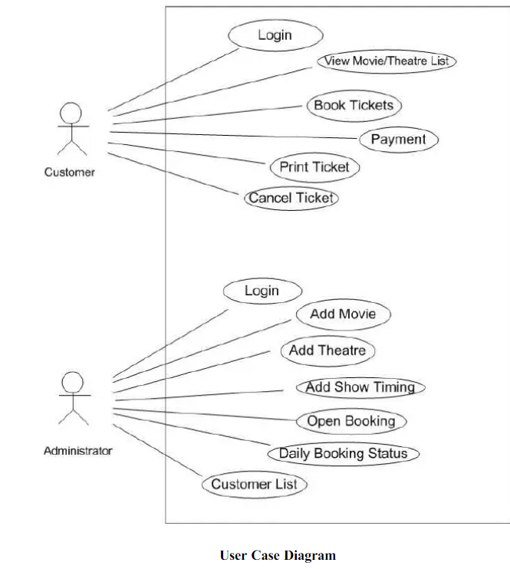

### Product Functions

The major functions that **Pick Your Flicker** performs are described as follows:-

* + - * The users can log into the system to perform different operations.
      * The customer can modify their own data.
      * The timing of the shows is set by the theatre owner.

### User Characteristics

The user types that would use the “Pick Your Flicker” are:

**Administrator:** Administrator: Administrator can easily do anything on the

site, in all pages. Administrator is responsible for updating and

maintaining the web site.

**Customer:** Customer is people who must have to register

themselves to use “Pick Your Flicker“. To use the service people

should have a basic computer using ability.

**External User:** External users are people who have not got any

user account for website.They can access only general

information.

### Constraints

General constraints that must be followed for efficient use of

system are:

**Regulatory policies:** It is a mandatory that no text box must

be left empty or contains insufficient data.

**Control function:** The software must be very user-friendly and

display appropriate error messages.

**Reliability Requirements:** Data redundancy and use of

special/blank character must be avoided.

**Higher Order Language Requirements:** The server

application should be available 365 days 24x7.

**Security and Safety Issues:** Username, password both are

considered as security issues.

### Assumptions and Dependencies

The requirements stated in the SRS could be affected by the following factors:

* The user must be able to use internet.
* User must have connected to internet to use the system.
* The computer must be Windows 95 or later version platform.
* The TCP/IP protocol must be installed to communicate through HTTP/HTTPS messages.
* Accuracy of the information of the user is the responsibility of the user itself.
* User can give comments and feedback about his experience on the site.

### External Interface Requirements

* + 1. **User Interface Requirements**

PICK YOUR FLICKER (Online Movie ticket booking) project description:

**1).USER :**

* User is responsible for the registration of the User Account, The user can Change password, view and booking the tickets.
* User can view all the movies and choose the movie.
* Then user can view time slots and needs to choose the available time slot
* After choosing time slot, user needs to check all details and confirm the movie slot
* User can view the booking details.

**2).ADMIN :**

* Admin Can maintain movie records.
* Admin: Can maintain User/Customers
* Admin can handle all the customers and manage the movie records like booking.
* And admin can handle the payment details.

## Hardware Interface Requirements

There are various hardware components with which the machine is required to interact. Various hardware interface requirements that need to be fulfilled for successful functioning of the software are as follows:-

OS : Windows/Linux

RAM : Minimum 2GB

## Software Interface Requirements

In order to perform various different functions, this software needs to interact with various other software’s. The system requires database for storing the information using oracle. At last the user need web browser for interaction with the system.

Front end- Angular

Server- Apache Tomcat Server

IDE- Eclipse

Scripting - Html ,Jsp, Bootstrap, Typescript

Back End - Spring JPA

### 4. System Features

1. **Customer Login Scenario:**

**Description**

The “Pick Your Flicker” manages all the movie ticket booking process and ticket amount payment process. This maintains information of list of all currently running movies in different multiplex of the same company in various location. The process of booking movies tickets online is kept very simple. The customer can go to the online ticket booking portal where they can see list of all movies running currently in different cinemas situated in various location and cities, different show timing etc. The customer selects their desired cinema, movie, preferred date, show timing, desired no of tickets and see the booking status or available seats. Then customer register itself on the portal and reserve his desired no of seats. In the next step system ask customer for payment online. After successful payment the system will generate movie ticket.

All registered customers can login to the ticket booking portal and see their previous ticket booking status. They can cancel their ticket by logging into ticket booking portal. Customer can also get cinema address from this booking portal.

1. **Security and Ticket Management Scenario:**

In this scenario we (admin) will manages all information about the movies like adding new movies, removing movies from the list and will manage all the records related with the making a movie show timing schedule for showing different movies in different show timings etc.

## Error Handling/ Response to Abnormal Situations

If any of the above validation/sequencing flow does not hold true, appropriate error messages will be prompted to the user for doing the needful.

### Other Non-functional Requirements

* 1. ***Performance Requirements***

The following list provides a brief summary of the performance requirements for the software:

## Login

## If a customer wants to book the ticket then he/she must be logged in website.

## List Movies

## The customer can view different movies.

## Book Ticket

User can view the movie then he/she can be able to book the ticket according to the slots

## 5.1.4 Movie Booking Details

It shows the details about the movies which user booked.

## 

### Software System Attributes

* + 1. **Security:**
* The system uses SSL (secured socket layer) in all transactions that include any confidential customer information.
* The system must automatically log out all customers after a period of inactivity.
* The system should not leave any cookies on the customer’s computer containing the user’s password.
* The system’s back-end servers shall only be accessible to authenticated administrators.
* Sensitive data will be encrypted before being sent over insecure connections like the internet.

## Reliability:

* The system provides storage of all databases on redundant computers with automatic switchover.
* The reliability of the overall program depends on the reliability of the separate components. The main pillar of the reliability of the system is the backup of the database which is continuously maintained and updated to reflect the most recent changes.
* Thus the overall stability of the system depends on the stability of container and its underlying operating system.

## Availability:

## The system should be available at all times, meaning the user can access it using a web browser, only restricted by the downtime of the server on which the system runs. In case of an of a hardware failure or database corruption, a replacement page will be shown. Also in case of a hardware failure or database corruption, backups of the database should be retrieved from the server and saved by the administrator. Then the service will be restarted. It means 24 X 7 availability.

## Maintainability:

A commercial database is used for maintaining the database and the application server takes care of the site. In case of a failure, a re-initialization of the program will be done. Also, the software design is being done with modularity in mind so that maintainability can be done efficiently.

**5.2.5 Portability:**

The application is HTML and scripting language based. So The end-user part is fully portable and any system using any web browser should be able to use the features of the system, including any hardware platform that is available or will be available in the future.

An end-user is using this system on any OS; either it is Windows or Linux.

The system shall run on PC, Laptops, and PDA etc.

**5.2.6 Accessibility:**

The system will be a web-based application it is going to be accessible on the web browser.

**Sample ScreenShots**

